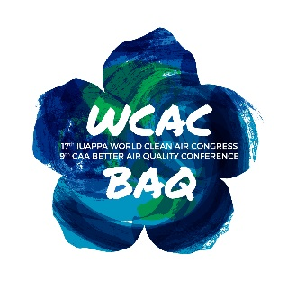
17th IUAPPA World Clean Air Congress and
9th CAA Better Air Quality Conference
29 August – 2 September 2016
Busan, South Korea

Offline Join Form
- PERSONAL PROFILE
Username(ID)* Title First Name* Middle Name Last Name*
SuffixSuf
Gender* | ☐ |  | Male | ☐ | Female
Job Title* |  | Click here to enter text. |  |  |  |  |  | Organization* | k here to enter text.
Nationality* |  | Click here to enter text. |  |  |  |  |  | Organization Type* | Click here to enter text.
Address* |  | Click here to enter text.
City |  | Click here to enter text. |  |  |  | State/Region | Click here to enter text. |  |  | Country | Click here to enter text.
Postal Code |  | Click here to enter text. |  |  |  | Affiliation | Click here to enter text.
Phone |  | ter text. |  |  |  | Email* | Click here to enter text.

Registration Fees*
Registration Package | Category | Early Bird Registration  (before 3 June 2016) | Regular Registration (after 3 June 2016)
Full Conference Package (inclusive of Gala Dinner) | Standard | US$ 600 | US$ 750
Full Conference Package (inclusive of Gala Dinner) | Student | US$ 300 | US$ 400
Gala Dinner | Standard | US$ 100 | US$ 100
* For student/s, kindly attached a student certificate or similar document from a recognized educational institution verifying your student status upon submission of the Offline Join form.

Payment Method*
Please select your payment preference below.
Online payment via Credit Card | You can register online anytime you want on our website. Automatically, a receipt of payment will be sent to you after the registration. Please note, to avail the Early bird rate before 3 June 2016.
Telegraphic Transfer | A receipt of telegraphic transfer will be sent to you after submission of the registration form. Please note, to avail the Early bird rate, Offline registration Form should be submitted on or before 3 June 2016.
Others | Please indicate: Click here to enter text.
Note: Marked in asterisk* are mandatory field
Please send Offline Join Form to iuappa@wcac2016.org or baq@cleanairasia.org

